Hi Erik and Leonard,

Ah sorry, I indeed forgot to tell you that blue arrows means positive correlation (actually regression) while red stands for negative link. I am so used to it that I completely forgot to mention it…

11% of the variance is not that bad, after all. I have been talking a bit with Göran Sundblad, and he said that he is normally happy if he get to explain 10% of the variation in fish population. He also told me that pikes in the coastal areas seem to do better in the south, but they don’t have data for adults and they don’t know why. Maybe there are more suitable recruitment area. I am curious to see whether we see this pattern also in stream water, which can help understanding the mechanisms behind it, and may have cascading effects on trouts. So I will test effect of latitude or climatic variables on pike and the interactive effects of pike and latitude on öring.

I will also run analyses on data from rivers that has been sampled at least three years, as you suggested.

About the negative effect of seasonality (Julian date) on LWD, it could be indeed caused by LWD migrating downstream, and it should be possible to see such an effect when including an interaction between distance from the sea and Julian date – I ‘ll let you know. Alternatively, it could be a spurious correlation, or an underestimation in the field due to turbid water, in which case we can not do much besides acknowledging it in the paper.

The predictors used were chosen through a 3-step process: first I grouped predictors based on their ecological meaning, e.g. climatic variables, geographic/connectivity-related, biotic, local features, temporal variability etc etc. Then I run a PCA and had a look at collinearity. Finally I included in the models predictors that were not highly collinear and test different alternatives to check which one would give a better fit (but giving prority to ecological meaning). To make sure things were right, I run VIF (variance inflation factor) on each separate model of the basis set (basis set=the group of models included in the SEM, each one explaining a different response variable).

Good point about trout type, whether they migrate or not can make a difference. I thought we said to skip it (I have a variable called “Typ_of_migration”), because it was not very reliable, but I may well be wrong. I see that there are lots of NAs so I am not sure it will work but I’ll give it a try. Was the type of migration referred to öring or salmon? I mean, what species does it refer to among all those sampled?

I did run analyses using fish species other than öring as binary, as indeed they occur in lower numbers. Results do not change much, only slight variations in the coefficients. I thought that for the sake of consistency if I consider öring as continuous that it was more elegant to do the same with the other species, but we could use absence/presence and justify it.

About adding more explanatory factors: yes, we should definitively discuss it. We need to weight the possible usefulness on the time that will take to extract this info. Before running stat I made up my hypotheses based on current evidence and literature (see figure below).

I marked with dotted red text boxes those parameters that are likely to influence either LWD or öring or both. Tree species, type of forest, biomass of trees, i.e. attributes of the forests around in the area are likely important (Roni et al. 2014).

The presence of dams or obstacles may be another key factor for fish. I guess that it is easier to get info on the number of dams per catchment rather than calculating the distance from the dam for each sampling point? Note that I am using averages per river right now, and not per site. It was not an easy decision considering that 1) some sites actually correspond to different spot, i.e. we sometimes have different lat and long coordinates for the same site, 2) there are many NAs, which may actually come from different sites, 3) most sites have been sampled not more than 2 times, which makes it hard to account for temporal correlation between samples while at the same time consider year as explanatory – issues of pseudoreplication, 4) not to loose information and homogenize everything, I tried to average where the variability is lowest: either from year to year or between sites of the same river. Eventually I went for the latter one, as I was interested in looking at the effects of time (year). However, I can take a step backward and consider sites as my replicates rather than river. It’s more complicated from a modeling perspective given the issues listed above but not impossible.

Then, if I get the model to work it makes sense to calculate distance from the closest dam, but right now I could only use number of dams (other obstacles?) per catchment or even better per river. Is that info available?

Yes, we definitively need a meeting ☺!

Leonard and I will talk tomorrow and come back to you. If we are not coming to Örebro we can talk through video.

Cheers!

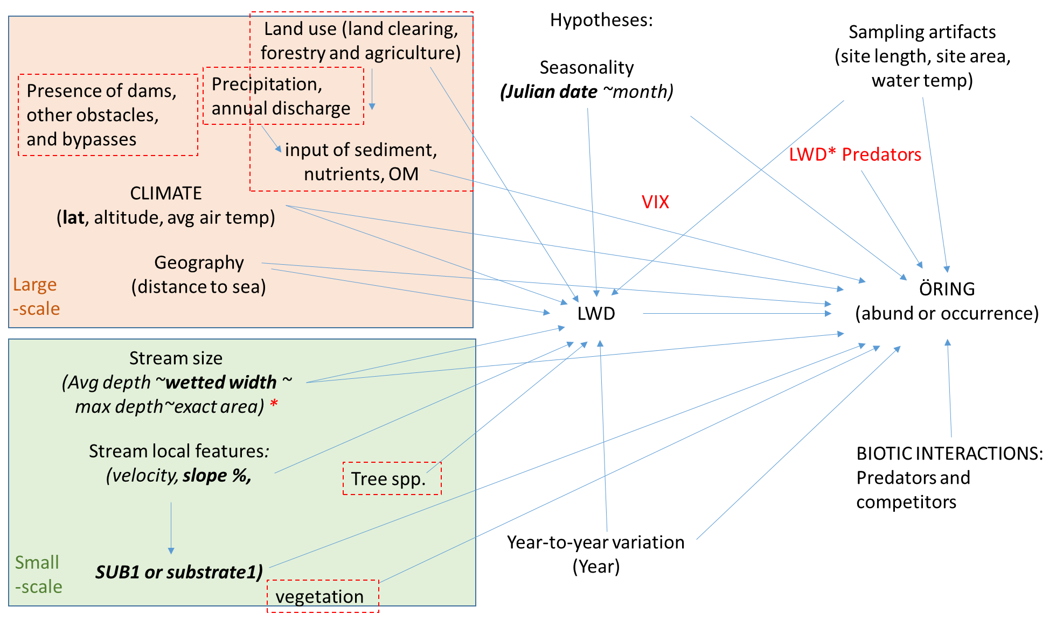

Ciao Serena et al.!

Nice chart - After a while we figured out that red arrows meant decreasing and blue increasing (positive correlation) abundance of trota.

We have discussed your results at the Örebro office and found them interesting and relevant, although only 11% of the variation was accounted for. As you suggest using averages for each site would increase the predictive power, but then the number of sampling occasions, sampled area or the cumulative number of runs may infer with the results. Sic! However, if there is still time left such a test would be interesting. Perhaps only sites visited at least three year should be allowed into the data set?

The only thing that strikes us as odd is the effect of Julian date on LWD. Carl had an interesting theory that LWD migrates down-river late in the season for overwintering. I think he was pulling my leg...Rather the explanation may be so simple (and tragic) that later in the season water levels are higher and the water more turbid. Perhaps some of the LWD then is overlooked?

That trout abundance decreases with Julian date is known. It is due to successive mortality as the young grow and deans more space (the total biomass remains the same).

We are not quite clear if the predictors used are the ones left after a cross-correlation test (i.e. distance to sea and wetted width were both highly correlated to catchment size so the latter was omitted).

Surely air temp is an important predictor of trout abundance, giving higher productivity at lower latitudes and altitudes. But, another factor influencing abundance is the type of trout population, sea-/lake-migrating or stream resident. That information on life history is included in the data set (vtyp). When trout is migrating the competition between adults and young fish is lessened and the abundance of fry/parr increases. Perhaps this is a confounding factor in the data set? I don't remember if we sent data on both life histories.

The classification of predictors is really nice with super-, meta- and macrohabitat and adding temporal variability and biotic interactions. For the latter you should use presence/absence at the site as an average for all sampling occasions. This is due to that they occur in low numbers and the sampling may not be sufficient with regard to size of site or number of runs to catch a single specimen.

The effect of year on LWD is well known and depends on large storms (named Gudrun, Per and Leonard etc) that have rendered much LWD since 2005/2008.

But there is room for improvement. Calle and I discussed adding quality GIS-data to all sites. Calle suggested, forest cover, biomass of tress, type and age of trees and so forth in a restricted areas around each site. Surely, LWD must depend on the surrounding areas. As I have put together data sets to a lot of people the last year the safest thing would be if you sent the coordinates of the sites to Calle so he could do the work.

And while he is at it - are we lacking more data? You suggested dams or a measure of connectivity. One way of making things easier for us is to use the life history variable instead (Vtyp=Hav or Insjö=migrating, Vtyp=Ström or lack of information = Stream resident). But certainly Calle can add data about migration obstacles, but they are hard to present in a quantitative manner. What would be adequate -number of dams per catchment, distance to nearest dam?

It surely feels as we could benefit from a meeting. We hoped you and Leonard was due here this week, but obviously not. A suggestion is that Calle adds some data after you've sent him the coordinates. Giving you some days to look at the new data we might have a meeting via Lync. I know that Leonard is often busy, but Calle and I may be available.

Cheers

Erik D

med vänlig hälsning

(:rik Degerman

Sötvattenslaboratoriet, Inst. för akvatiska resurser,

Sveriges Lantbruksuniversitet (SLU Aqua)

**Från:** Serena Donadi  
**Skickat:** den 6 mars 2017 10:05  
**Till:** Erik Degerman; Leonard Sandin  
**Ämne:** öring abundance - some results

Hi Erik and Leonard,

I have been running some more analyses, including potential predators and competitors and also the influence of stream slope on both LWD and öring abundance.

I end up with a final best model (check it out on the attachment, sorry for the ugly figure) where öring abundance is explained by a mixture of different large- and small-scale abiotic factors, and the abundance of predators such as lake (Burbot) and pike. LWD has a positive influence on öring and is in turn dependent on the abiotic environment and temporal variability (increases over years and decreases at the end of the summer). The strongest link in the model is the (negative) link between average stream depth and öring abundance. I didn't add the magnitude of the effects of the factors in the model for sake of graphical clarity.

With such a  model we can explain 0.11% of variation in öring abundance and 0.11% in LWD, while river identity explains respectively 70% and 40%. In order to be able to explain some more of the between site variability, we would need to include and test other potential factors (land use, tree species, discharge, presence of dams...). We can discuss about it. Also, I might have missed important link or interactions, and you are welcome to bounce ideas.

I tested the effects of the interactions between LWD and predators on öring, as LWD may be more important when predators are present, but they were not significant. Also, I tested the interaction between LWD and stream width, as from your previous results Erik it looks like LWD may be more important for wider streams. But again, no significant interactions.

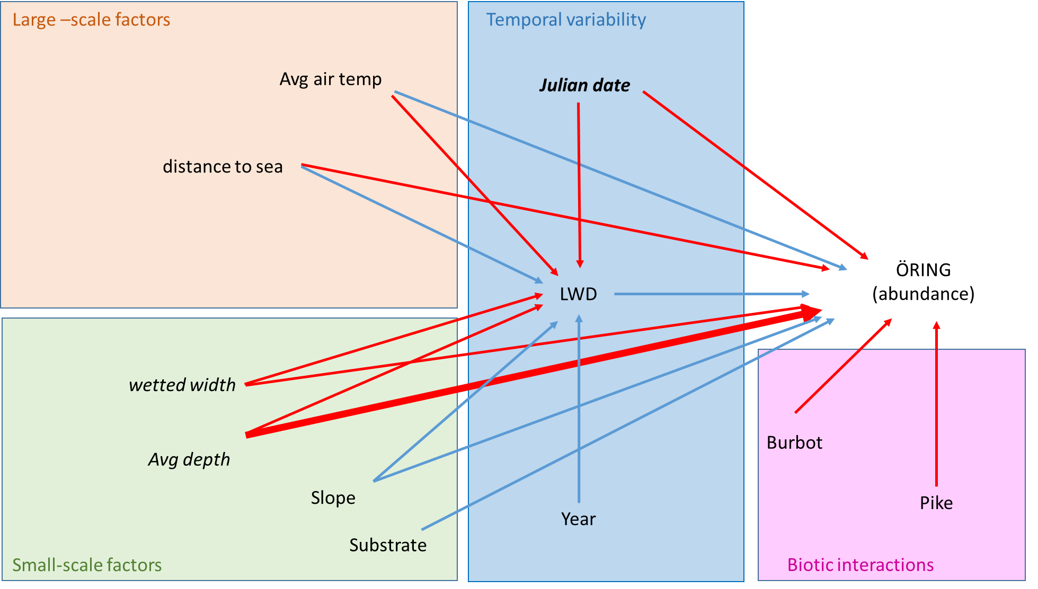

When considering also burbot and pike as endogenous (response) variables (in the same model used for öring abundance), I get to explain very little variation in their abundance, 0.02% for both of them.

Using presence/absence data instead of (log transformed) abundances doesn't help much in term of explained variation, and add the problem of temporal correlation, which is not possible to model with binomial error distributions when a spatial correlation is already included.​

I checked for sampling artifact by looking at the relationships between öring abundances and site length and site area, but it looks fine, i.e. no clear relationship. There is a positive link between öring and water temperature, which could partly be due to increased catchability when waters are warmer, but we can not account for such potential artifact as water temperature covary with climatic variables such as air temperature and latitude and altitude. So I decided to use average air temperature in the model and avoid potential critics.

Last, I also included VIX in the model. I know that VIX is estimated based on various abiotic parameters, but didn't get whether is somehow derived also from öring abundance. VIX shows a pretty good correlation with öring abundance but I am hesitating to include it in the final model, as it goes somehow against the whole purpose of having such a complex model, which is to understand what factors are contributing the most, rather than pooling them together in an index. And if furthermore VIX is not independent from öring, it does not make sense to include it.

Concluding: I am quite happy with how the model turned out, but I wonder whether 11% explained variation in öring abundances is a relatively good achievement.

What I could do (and I have already started doing but with no stunning results), is to average data by site (over year), or consider only a specific year, or subsetting data in whatever othe way - thought are welcome. The aim is to get a more homogeneous dataset, and average out some variation.

All in all, we should not forget that these data come from a country-wide area, and therefore we should expect high heterogeneity in climate, habitat and maybe communities. What are the key missing factors? Is this enough or can we include something more? Once we decide on this, we can consider what angle to use to wrap our story in and get a publishable manuscript.

Cheers!

Serena

Tussen tack! You are a walking library :D

So, the positive relationships between slope and öring, and slope and LWD make sense..

It may be a good idea to consider guilds. My experience with freshwater systems is still limited and I may need to ask you later on how to pool species in different guilds.

As a snapshot of the outcome reached so far: it seems like LWD has a positive effect on öring abundance, which is not evident in a simple linear univariate model, but becomes apparent when modeled in a structural equation modeling framework, i.e. considering both direct and indirect relationships among interrrelated factors. On both öring abundances and LWD, we see the influence of large scale factors such as climate (air temperature) and connectivity (distance to the sea), and local factors such as stream width and depth.

However, most  variation (40-70%) seem to be explained by river (as random factor), i.e. unmeasured attributes that vary specifically with the rivers considered, while only 10% is explained by covariates. Therefore, it looks like we are missing some important explanatory factos - as it always happens when our poor minds trying to explain the complex nature of a coutry-wide system. To increase the predictive power of our models (and the knowledge of the system), we may consider the idea to include in the analyses information on the presence of dams or other obstacles, and bypasses, and on land use and discharge. Of course I have no idea whether this information is available and easily collected.​

I will further work on the models I have so far, and send out something for you to have a look soon. Then we may also decide to skype or meet if necessary.

Ha det bra!

Serena

~~~~~~~~~~~~~~~~~~~~~~~

Serena Donadi

Forskare/Researcher

Sveriges lantbruksuniversitet  
Swedish University of Agricultural Sciences  
Institute of Freshwater Research / Department of Aquatic Resources

Stångholmsvägen 2, SE - 178 93 Drottningholm

Tel: +46 (0) 76 24 14 704

serena.donadi@slu.se, [www.slu.se](http://www.slu.se/)

Mark as unread

Erik Degerman

Mon 27/02/2017 08:56

 3 attachments

|  |  |  |
| --- | --- | --- |
| [Degerman_Nä~.pdf](https://webmail.slu.se/owa/service.svc/s/GetFileAttachment?id=AAMkADQ1Y2RlN2UwLTFkY2QtNDM4Zi1hYzQ0LTVjN2MwMDI4YjRlNABGAAAAAAA%2Brb6sunCQR5KmVvdcBSgVBwDz%2F4uj8TxwRr36IlCrueVsAAAAAAEMAADz%2F4uj8TxwRr36IlCrueVsAABPtcDYAAABEgAQADN0AdXjx7VBj5BLdE7Yla8%3D&X-OWA-CANARY=LC_GlA01dkGdqeEUgjicD3unKDbYZtQIdSeUJ6F6TtFHt1pFH_tJhYt712cOtOP44t21lUT2_3o.) | [Öhlund_2008~.pdf](https://webmail.slu.se/owa/service.svc/s/GetFileAttachment?id=AAMkADQ1Y2RlN2UwLTFkY2QtNDM4Zi1hYzQ0LTVjN2MwMDI4YjRlNABGAAAAAAA%2Brb6sunCQR5KmVvdcBSgVBwDz%2F4uj8TxwRr36IlCrueVsAAAAAAEMAADz%2F4uj8TxwRr36IlCrueVsAABPtcDYAAABEgAQAOFO4nniw7lOuzHvUept13M%3D&X-OWA-CANARY=LC_GlA01dkGdqeEUgjicD3unKDbYZtQIdSeUJ6F6TtFHt1pFH_tJhYt712cOtOP44t21lUT2_3o.) | [Nordwall_Br~.pdf](https://webmail.slu.se/owa/service.svc/s/GetFileAttachment?id=AAMkADQ1Y2RlN2UwLTFkY2QtNDM4Zi1hYzQ0LTVjN2MwMDI4YjRlNABGAAAAAAA%2Brb6sunCQR5KmVvdcBSgVBwDz%2F4uj8TxwRr36IlCrueVsAAAAAAEMAADz%2F4uj8TxwRr36IlCrueVsAABPtcDYAAABEgAQAJr2AQ63D%2BJKiE3bkhQVMgo%3D&X-OWA-CANARY=LC_GlA01dkGdqeEUgjicD3unKDbYZtQIdSeUJ6F6TtFHt1pFH_tJhYt712cOtOP44t21lUT2_3o.) |

Download all

Hej Serena,

Don’t ever hesitate to ask. The only problem is that I try to be off work on Fridays. Therefore this late answer. On top of that I am off to a meeting at 09:30 about a new hydropower plant & fishway that SLU wants to build (might be a project in the future).

As for your first question the occurrence and abundance of trout usually increases with slope up to 5-10% slope. This is because few competing species and predators can live in such rapids, giving trout an opportunity to expand. As for LWD it is more about where it gets stuck. In low slope rivers the bottom is often with finer substrate, sand, gravel, which is not so god at retaining LWD. In areas with higher slopes the bottom is coarser (stones, boulders) and LWD easily get stuck between boulders.

Question 2. There is a nice negative correlation with trout and the number of other fish species. It is a poor competitor and predator, and often suffers from predation. The main predators are pike and burbot (Lota lota). We have good evidence on this.

As for other important species/taxa you might include:

Cottus spp – one of the few species complex that brown trout holds down by predation on their young. If trout is absent, Cottus expands its niche.

Brook trout and brown trout are competitors, but there are quite few cases with both species in your data I guess? Anyway, I enclose a paper on the competition of the two species.

Young trout and grayling also compete the first summer. Then they use different habitats. Paper enclosed.

Salmo salar and trout certainly compete in fast flowing waters. I’ve only written some PM:s about that as I recall. We have a paper: Milner, N.J., Karlsson, L., Degerman, E., Johlander, A., MacClean, L.P., Hansen, L-P. 2007. Sea Trout (*Salmo trutta* L.) in European Salmon (*Salmo salar* L.) Rivers. In: Sea Trout: Biology, Conservation & Management. pp. 139-156. Blackwell Publishing Ltd, Oxford.

But I don’t seem to have it myself (☺). I’ll ask Nigel Milner to send it.

As for roach, stickleback, minnow, Arctic char and Lampetra there are no direct interactions.

Otherwise I’d recommend to not include too many species, but rather use guilds, i.e. species that for instance prefers lotic or limnophilic environments. The latter, limnophils, usually increase when there is a disturbance of habitat diversity or water flow alterations.

Cheers Erik

REPLYREPLY ALLFORWARD

Mark as unread

Serena Donadi

Fri 24/02/2017 14:30

Sent Items

**To:**

Erik Degerman;

**Cc:**

Leonard Sandin;

Hi Erik,

Hope all is good there! I have a couple of questions, I thought to wait and ask you when we meet, but realize that  if you have a preliminary answer I can already tune my models :)

I am modeling  öring abundance from the large dataset that you gave me, and I use many abiotics as explanatory factors, and LWD as mediator.

Question1: it looks like percent slope of the stream may have a positive influence on both LWD and öring, which to me does not make much sense. Do any of these possible sense make sense to you? If  not, it's just spuriousa correlation and I would treat it likewise.

Questions2: I d like to include in the model possible interspecific interactions that may affect öring abundances. As far as I know, pikes can be a predator of öring, and indeed I find a negative effect of pike on öring. However, other species give positive or negative response. So if you can give me any insights on predators and competitors among our fish species it would be great. I will look into the literature, but thought to ask you first, as I much more like playing with models :)

The fish species that I am considering as explanatory variables and possibly also as response (due to their relevance in term of abundance, ecological or economical value) , are:

perch, brook trout, minnow, pike, grayling, burbot, Salmo spp, brown trout, roach, stickleback, rainbow trout, artict char, Cottus and Lampetra.

If I miss any important spp let me know.

Of course it's Friday, no hurry with this, I keep on playing :D

Cheers,

Serena

ASK Erik about catchments and tributaries to solve spatial replication issue

Öring=Salmo trutta (brown trout)

Bäcrö=Salvelinus fontinalis (Brook trout, an introduced species; bäckröding).

The species name in SERS (öring, bäcrö, gädda, mört) consists of an abbreviation (if needed) of the swedish name for the species.

As for brown trout we have the total sum of brown trout = Öring_tot.

This can be divided into:

Fry (the first cohort born the same year as the sampling) is called öring 0+.

Parr and older trout (they are older than 0+) are called öring.

Öring 0+ and Öring together = Öring_tot.

Cheers Erik

☺

Don’t be sorry that you have questions.

1)Lax=Salmon - Is this *Oncorhynchus*? No, it is **Salmo salar**

2)Laxfix=Unknown salmon - may include the above as well? or the below-mentioned spp.?

**This is unidentified Salmo species; Salmo salar or Salmo Trutta.**

3)Laxör=Hybrid Salmo trutta * Salmo salar = ok, I got it YES

4)Öring=Brown trout - which according to Wikipedia should be*Salmo trutta*, eller? **sì**

​

Keep asking & have a nice weekend

Erik

Hej Serena, "mi scusi" for at late reply.

As for your questins:

1. Look at enclosed ppt.

2. Wetted width is the width of the stream, and site width is the width of the site investigated. It is explained in the sheet in the data file. So if the wetted width is 20 m and they only electrofished 10 m from the shore, wetted width will still be 20 m, but site width 10 m. I should consider only data where site width = wetted width

3. Yes, maxdepth is the maximum depth of the sampled area, not the river. It is not possible to wade into 3,5 m, naturally. But they may have used a long stick to measure the depth. Although inexact, they may be a good estimate. As for the site length, check whether estimates depend on the sampling depth.

4. The temperature included in the data set is the actual (ambient) water temperature at sampling. This will affect sampling.

The average air temperature is more a proxy of the climate, another important driver of the fauna. Temp problem not solved

5. Shade is the proportion (%) of the river (not the site) that is shaded from the sun during midsummer. This is guesstimated and I would not give to much focus on this right now.

6: I tried to explain this, but understand that it is confusing. Salmo trutta (öringtot) may be divided into the number of trout fry (Öring0+) and the number of parr and older (Öring>0+). I suggest using only the total for the species, not to use the number of fry and parr separately. We can discuss this further so that I can explain the data set.

As for the errors in the data:

1- This watershed (catchment) runs into Norway and we can not estimate the area.

2-4% is not in the database. It happened when I made an Excelfile. It should be "4".

3-Apocalypse is certainly here - but this is older data where we only know the year of sampling, not the exact date. I suggest omitting.

4-As for -0,1 this is not within the database. Must be my error when extruding the data. I have checked now and it was another error when extracting the data. Sorry, but when extracting there are some data missing (due to actual circumstances) and I tried to fill them in automatic. Almost successful...

Get back to me or Berit if there are any more questions!!

Buona notte!

(:rik Degerman

Hej Erik!

I know you are in Umeå, so no stress with replying -  I will be back to action on Friday but have plenty of stuff to work on :)

I need to well understand what factors could potentially drive fish abundance/occurrence and what factor can instead affect the accuracy of the estimates (and what factors may have both effects, such as temperature for instance) - basically ecological vs sampling issues.

So here are some questions to help me with the above problem plus some other things:

1) Does the tributary number tell me how many times "the water has split up", e.g. 3 means that the main stream has split up 3 times? If so, what does 17 12 2 mean?

2) What's the difference between "wetted width" and "site width"? what's "site area"? I mean, does it refer to the area directly surrounding the sampled river lentgh, and if so, how was it calculated?

3) Is "Max depth" the max depth of the sampled area? Do you know how it was estimated in the field? I see 3.5m...were they walking  or using boats? If so, is the efficiency the same, can we compare estimates obtained from both methods?

4) We talked about the temperature when we met in Örebro. Temperature can affect catchability of fish, that's why it would be good to have estimate of average temperature over longer time.

I remember you suggest to use air temperature but I guess that this was also taken at the time of sampling, and it fluctuates even more than water temperature.

Is there a way to get average air temperature in the area? I think SMHI should have these data available to the public..It may be a lot of work, given that we need to choose the weather stations that are closest to each individual site, so we can think about it, and maybe do it only for a subset of data.

5) Was "shade" estimated on the sampled area at the time of sampling(which is?)? Why is that relevant? Do we get more fish in the shade?

6) I see that we have 3 different salmon estimates: salmon, unknown salmon, and salmon trutta. Shall we pool any of these, i.e. salmon + unknow salmon?

​

Ok, that's enough for now :D

We can also take it on the phone if that's more practical.

Also: I found few mispelling/errors in the dataset, just in case you want to correct the original database:

1) ​Catchment_area_class is blank in one of the sampling done in Luckholmen sydon, catchment 053

2) I found "4%"  (2x) as a value in "substrate class" (and replaced with 4)

3) Under "month" you will find a zero. Apocalypse?

4) Brown trout abundance: there is a -0.10, I put 0.8 based on the number of adults

Cheers!!!

Serena

Diversity

There are few fish species in a Swedish stream and river. Normally only 2-3 species are caught at a site. This means that different diversity indices are quite meaningless. Sometimes we use Simpson diversity index, but I recommend not to – as chance has so large effect on sites with few species and individuals. Certainly the number of species caught may be used as a proxy for biodiversity.

Species and taxa

The number of species…it is calculated from the observed number of true species (Excel column = DA). But to avoid effects of misclassification of some taxa I prefer that when we talk about abundance we should lump some species together;

Cottus = Simpor = Cottus gobio & Cottus poecilopus  (Excel column = CW)

Sticklebacks = Spiggar = Pungitius pungitius & Gasterosteus aculeatus (Excel column = CX)

Lampetra = Nejonögon = Lampetra fluviatilis & L. planeri (probably only one species; CY).

Abundance

LWD, the number of pieces of large woody debris, is counted at the electrofishing site after the fishing is completed. It is expressed as LWD per 100 m2. Also fish abundance (density) is given as number per 100 m2. These values are estimated in such a way that if you fish a site you normally fish it three times in a row, three runs. In the first run you may catch 50 fish. You keep them in a large container and fish again. Now there was only 25 fish caught. If you fish a third time you may catch only 12 fish. This is called successive removal or depletion fishing. A simple linear regression will now give you an estimate of the true number of fish at the site (even those that are still left uncaught in the water).

Salmonids

Salmonids are the only species where we divide the number of fish into two age classes; fry=0+ and older fish >0+. If you look at the abundance of trout (Excel columns = CS to CU) you’ll see that there is a possibility to use abundance of 0+ and >0+ separately or the total abundance (CU). I’ve highlighted the salmonids and you may choose whatever approach you prefer. My suggestion is to use the total abundance avoiding complications. As we catch the fish by wading in shallow water, large trout are seldom caught. The majority of the abundance is made up of small fish; fry 0+ and parr (1+,2+).

Size

I haven’t include all fish lengths. But there is an easy way to check for fish sizes – for trout (DE to DG) and eel (DC & DD). Here you have the smallest and largest caught individual of each species. For trout is also given the largest fry (0+) a sort of proxy of growth conditions at the site.

Ecological status

VIX (ecological status using fish) is calibrated so it can be used across all sites in Sweden. VIX is the probability that a site has good status. It is calculated from a comparison of the actual catch with a predicted catch for that site in pristine conditions. We have taken into consideration site habitat, slope, climate, altitude, catchment area, proximity to lakes etc.

Crayfish

The number of species at a site is calculated as the number of fish species, crayfish species (n=2) are not included. Whether to include crayfish in analyses or not can be discussed. However, we have shown that the abundance of crayfish (Excel column = CV) cannot be properly estimated using successive removal. This is due to that catch probability is not equal between runs. Crayfish are burrowed in holes during the day and only a low proportion is caught in the first run and more in the second, making our calculations useless.

Cheers Erik

Dear Serena,

There are two sheets, one with the data, one with an explanation to what the different variables represent.

As you will notice some sites (identified with X- and Y-coordinates in the Swedish grid) are only investigated once, others up to 20-30 times (once every year). This must be handled some way. You might use the data from only the last fishing occasion, or use an average of all available sampling dates. There are pros and cons to both alternatives.

I will write some more about how to handle these data, and we will discuss further on Friday.

Now I’m off in the field to look at a proposed hydropower plant/fishway.

Cheers

Erik Degerman

Hi again Serena,

My drawers a full of unfinished papers that were never finalized due to lack of time (and interest once the results were there). Here is a data set (Excel) and two outputs (Word) that Erik Petersson at our institute and I were working with in 2014, was it?

In the data set two columns are marked with yellow, these are the abundance (density) of trout per 100 m2 and the other column the number of pieces of LWD at the site. LWD is dead wood with a diameter of at least 10 cm and the length should be at least 0,5 m.

I just wanted to show you yet another approach to the problem with the effect of LWD, something in between the former two paper I sent.

I will produce a new data set (we have new data) so don’t worry too much about the enclosed one. I just wanted to give you a glimpse of what will come.

Cheers Erik

Dear Serena, welcome to SLU Aqua!

I hope we can have a fruitful cooperation. Leonard and I have discussed some future articles that could be produced using the data we already have in our databases. Much of the data of interest is in our Electrofishing database, that stores data on fish investigations in running waters using electrofishing. If you look at the recent paper by Cristina Trigal and me you can read a little bit about the data. That paper really started out from a question – what is he effect of large woody debris (LWD) on fish in lotic environments?

The other included paper is an older attempt to address the same question. Between these two papers we have done several more on fish in running waters, but not focussed on LWD as such.

Aim of the intended study is to evaluate if LWD has an effect on ecological status and dominant species occurrence/abundance. And further to see if this eventual effect depends on size of river (wetted width), slope and dominating bottom substrate - the coarser perhaps the less effect of LWD. (A future paper could focus more on traits.)

The background is that a power plant has a debris clearance system (screens) that makes  water downstream devoid of LWD. Often a large stretch downstream the power plant today is lacking water, a dry river bed. These sites were normally with fast flowing water as there is a high gradient (slope). If the power companies would allow that some water would be released downstream the old river bed would again produce a habitat for lotic animals. If so, would it be beneficial for fish and ecological status to artificially add LWD - will that structure have a positive effect even in wide and steep waters? Are there thresholds? We will answer this by looking at undisturbed sites in the database.

I will put together a set of data until Friday.

Cheers Erik

*One of the guys on the other side of the screen in our “enhetsmöte”, Monday*